School of Computer Science and Artificial Intelligence

Lab Assignment # 6.5

Program : B. Tech (CSE)
Specialization :
Course Title : AI Assisted coding
Course Code :
Semester : II
Academic Session : 2025-2026
Name of Student : R.Sai Kowshik
Enrollment No. : 2403A51L23
Batch No. : 51
Date :23-01-2026

Task 1: Use an AI tool to generate eligibility logic.
Prompt : “Generate Python code to check voting eligibility based on age and
citizenship.”
AI-generated conditional logic.
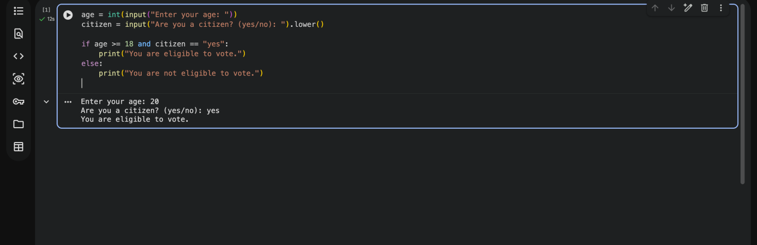

Explanation of conditions
- The program takes age and citizenship status as input.
- The if condition checks two rules
  - Age must be 18 or above
  - Citizenship must be “yes”
- The logical operator and ensures both conditions must be true.
- If both conditions are satisfied, the user is eligible to vote.
- Otherwise, the program prints not eligible.

Explanation of conditions.
- Age = 20, Citizen = yes → Eligible
- Age = 16, Citizen = yes → Not Eligible

Task 2: Use an AI tool to process strings using loops.
Prompt: “Generate Python code to count vowels and consonants in a string
using a loop.”

AI-Generated Code

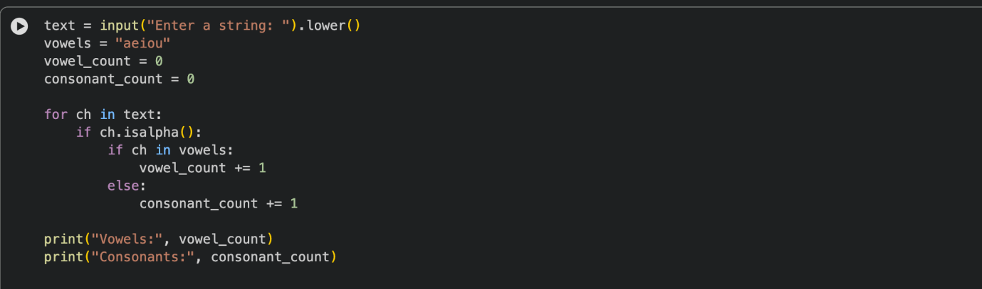

Correct counts.
- Converts input to lowercase
- Uses for loop to read each character
- Checks: Alphabet → vowel or consonant
- Counts correctly

Output verification.
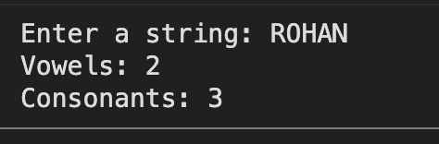

Task 3: Use an AI tool to generate a complete program using classes,loops, and conditionals.

Prompt: “Generate a Python program for a library management system using classes, loops, and conditional statements.”

AI-generated conditional logic.

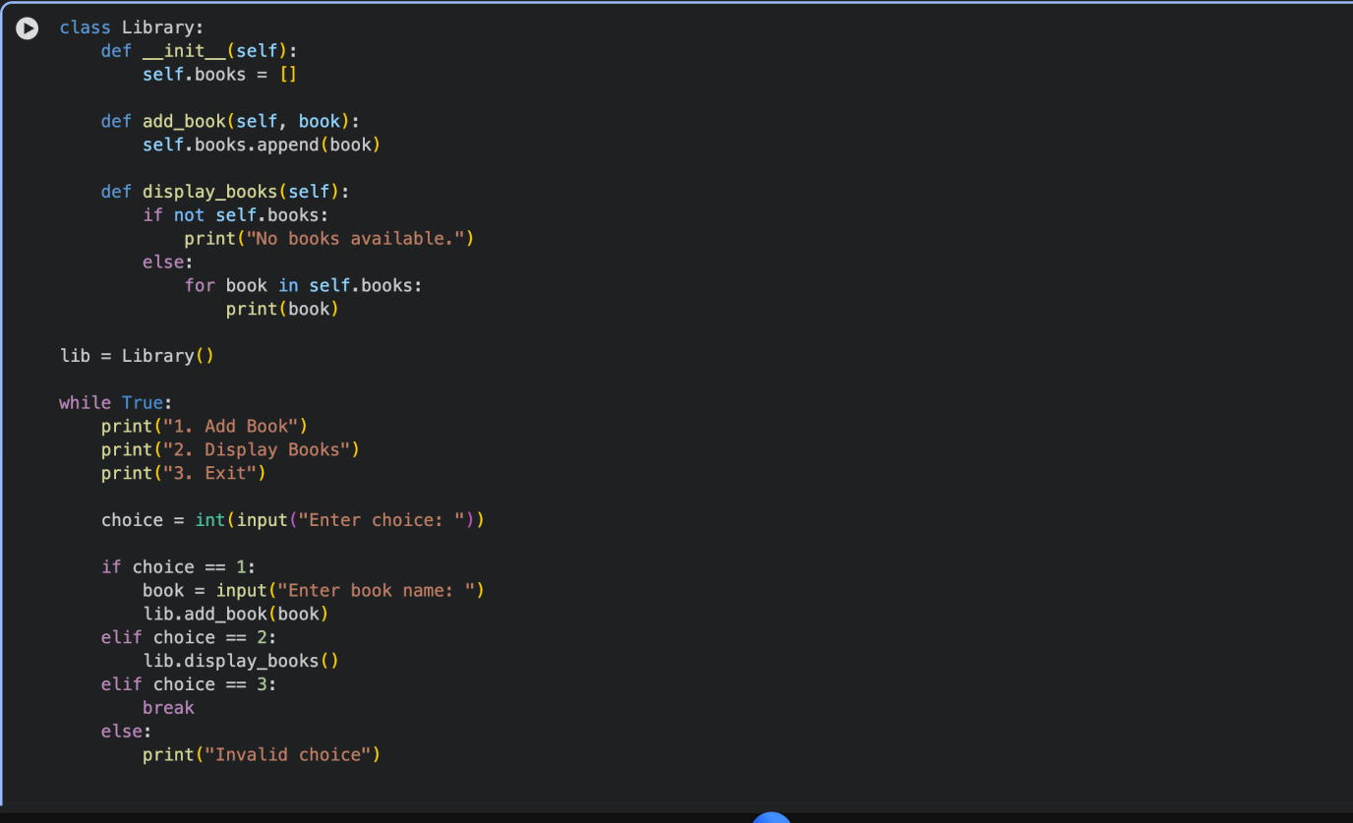

Review of AI suggestions quality.
- The AI correctly generated:
  - A class (Library)
  - Loop (while True) for menu repetition
  - Conditional statements (if-elif-else) for user choices
- Code is easy to understand and readable
- Uses basic data structures (list) efficiently
- Minor improvement needed:
  - Input validation can be added.
  - Exception handling for invalid inputs.

Short reflection on AI-assisted coding experience.

AI-assisted code completion helped in quickly generating a structured and functional program. It reduced development time and provided a clear logical flow using classes, loops, and conditionals. However, reviewing and improving the AI-generated code is necessary to ensure correctness, efficiency, and better error handling. AI should be used responsibly as a support tool while maintaining strong programming fundamentals.

Task 4: Use an AI tool to generate an attendance management class.

Prompt: “Generate a Python class to mark and display student attendance using loops.”

AI-generated attendance logic.
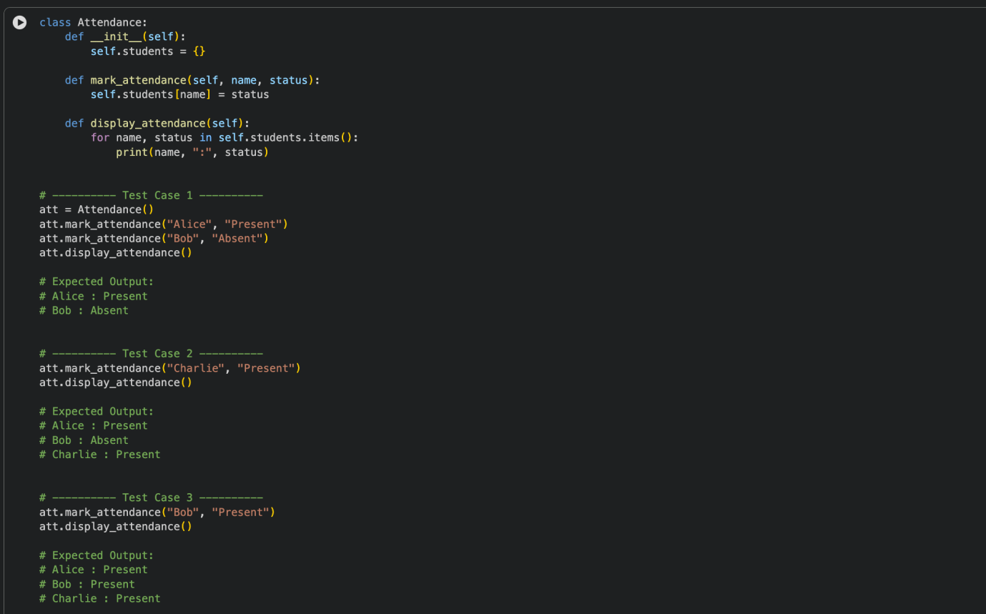

Correct display of attendance.
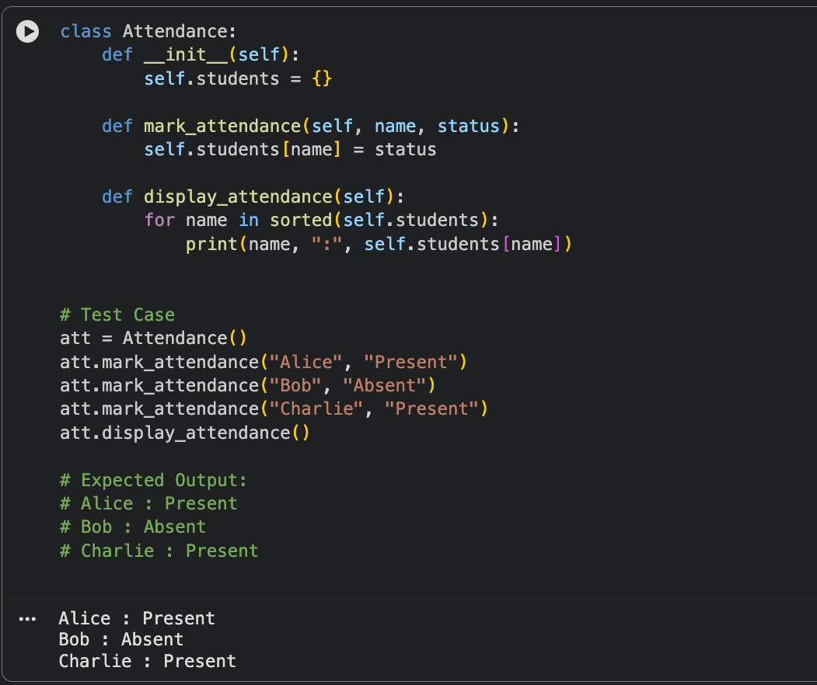

Testcases.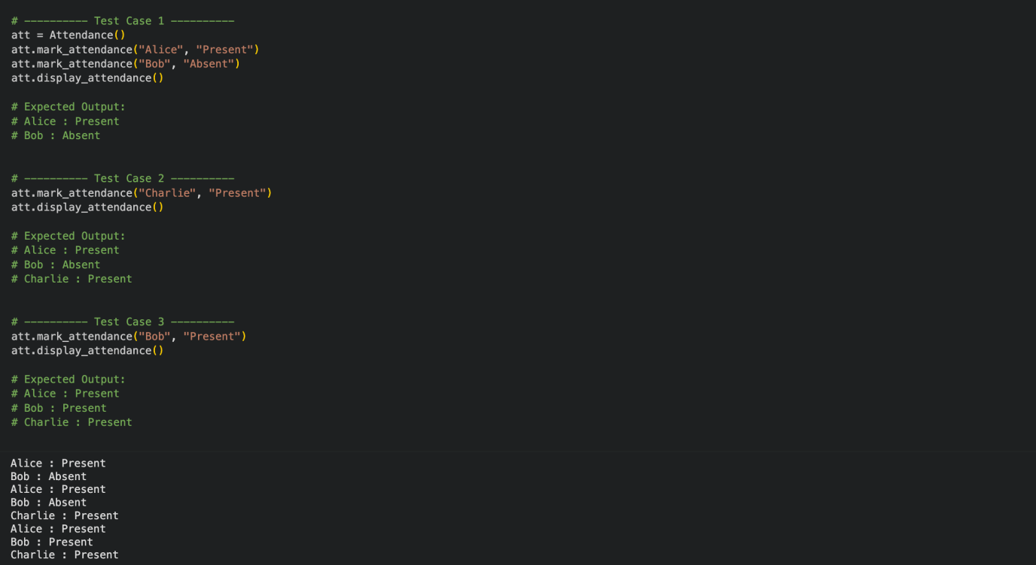

Task 5: Use an AI tool to complete a navigation menu.

Prompt : “Generate a Python program using loops and conditionals

to simulate an ATM menu.”

AI-generated attendance logic.
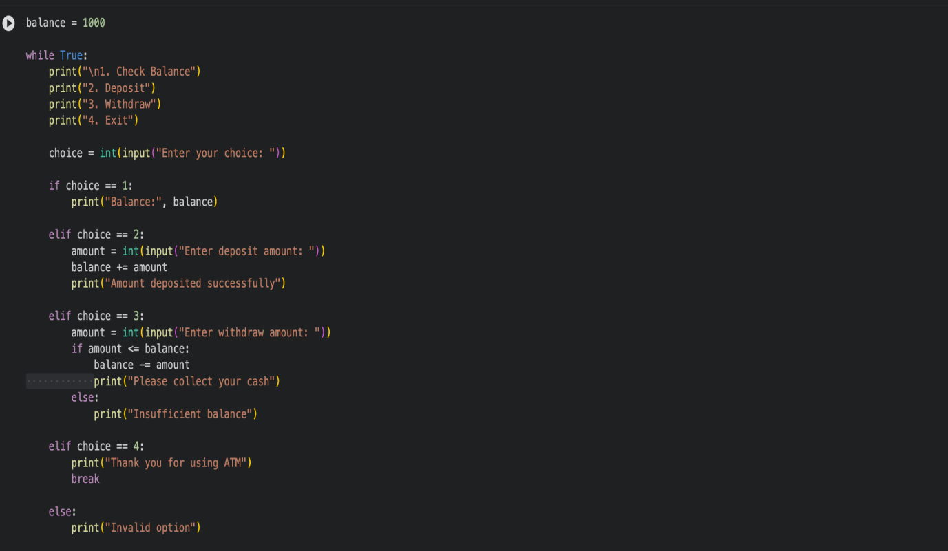

Correct option handling.
- Option 1 → Displays balance
- Option 2 → Deposits amount
- Option 3 → Withdraws if balance is sufficient
- Option 4 → Exits menu
- Invalid input → Error message

Output verification.

